
School: ............................................................................................................. Campus: ....................................................... Academic Year: ...................... Subject Name: ........................................................... Subject Code: ..........................
Semester: ............... Program: ........................................ Branch: ......................... Specialization: .......................... Date: .....................................
(Learning by Doing and Discovery)
* Coding Phase: Pseudo Code / Flow Chart / Algorithm
Create a .env file in your project Procedure to Set Up IPFS on Pinata, Generate API Keys, Upload via PowerShell, and Automate with JavaScript & .env

1. Create a Pinata Account & API Keys
Step 1 – Sign Up
1. Visit Pinata.cloud.
2. Click Sign Up and create your account.
3. Confirm your email to activate the account.
Step 2 – Generate API Keys
1. Go to API Keys in the dashboard.
2. Click + New Key.
3. Give it a name and enable:
o pinFileToIPFS (needed for file uploads)
o pinJSONToIPFS (optional, for uploading metadata)
4. Save the generated credentials:
o API Key
o API Secret
o JWT Token (used as Bearer token for secure requests)

2. JavaScript Automation Setup (Node.js)
Step 1 – Prepare the Project
1. Ensure Node.js is installed on your system.
2. Open PowerShell and run
3. Install dependencies
In the powershell:
npm install @pinata/sdk dotenv axios form-data
Step 2: Create .env File
root:
PINATA_API_KEY=your_api_key
PINATA_API_SECRET=your_api_secret
PINATA_JWT=your_jwt_token
Step 3: JavaScript Code (upload.js)

Coding Phase: Pseudo Code / Flow Chart / Algorithm
addFile.js :
require('dotenv').config();
const axios = require('axios');
const FormData = require('form-data');
const fs = require('fs');
const path = require('path');
async function uploadToIPFS(filePath) {
if (!fs.existsSync(filePath)) {
console.error("⚠ File not found:", filePath);
return;
}
try {
const formData = new FormData();
formData.append('file', fs.createReadStream(filePath));

const response = await axios.post(
'https://api.pinata.cloud/pinning/pinFileToIPFS',
formData,
{
maxBodyLength: Infinity,
headers: {
...formData.getHeaders(),
pinata_api_key: process.env.PINATA_API_KEY,
pinata_secret_api_key: process.env.PINATA_SECRET_API_KEY,
},
}
);
console.log("File uploaded to IPFS via Pinata!");
console.log("CID:", response.data.IpfsHash);
console.log(`View File: https://gateway.pinata.cloud/ipfs/${response.data.IpfsHash}`);
} catch (error) {
console.error(" Upload error:", error.message);
}
}
// Get file path from command-line argument
const filePath = process.argv[2] || "sample.txt";
uploadToIPFS(path.resolve(filePath));

* Softwares used
Environment / Tools: Frontend (React):
- VS Code React.js
- Node.js and NPM HTML/CSS
- Browser
- Terminal
Backend (Node.js):
- Node.js and Express.js Development
- Axios, Multer,Form-data
- Dotenv, CORS

- Testing Phase: Compilation of Code (error detection)
No Error

- Implementation Phase: Final Output (no error)
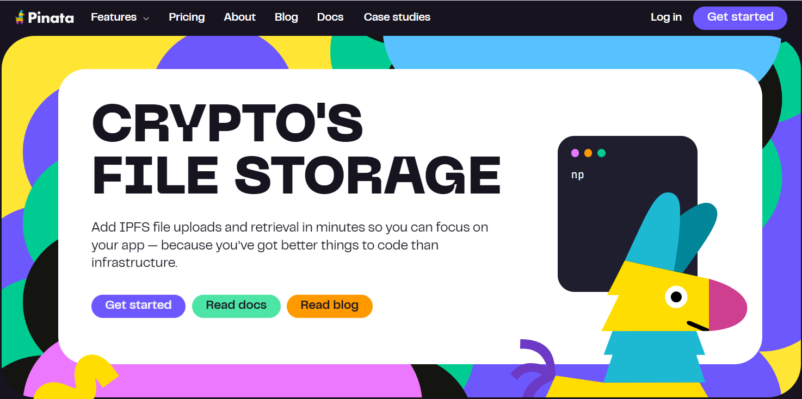

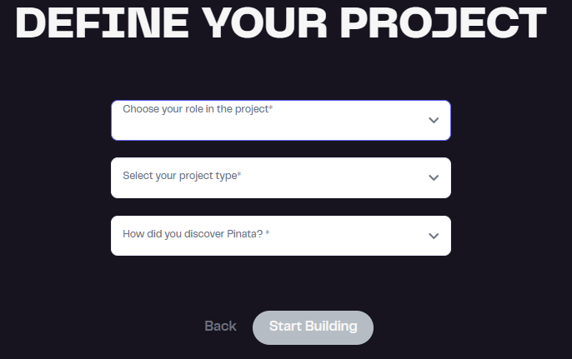

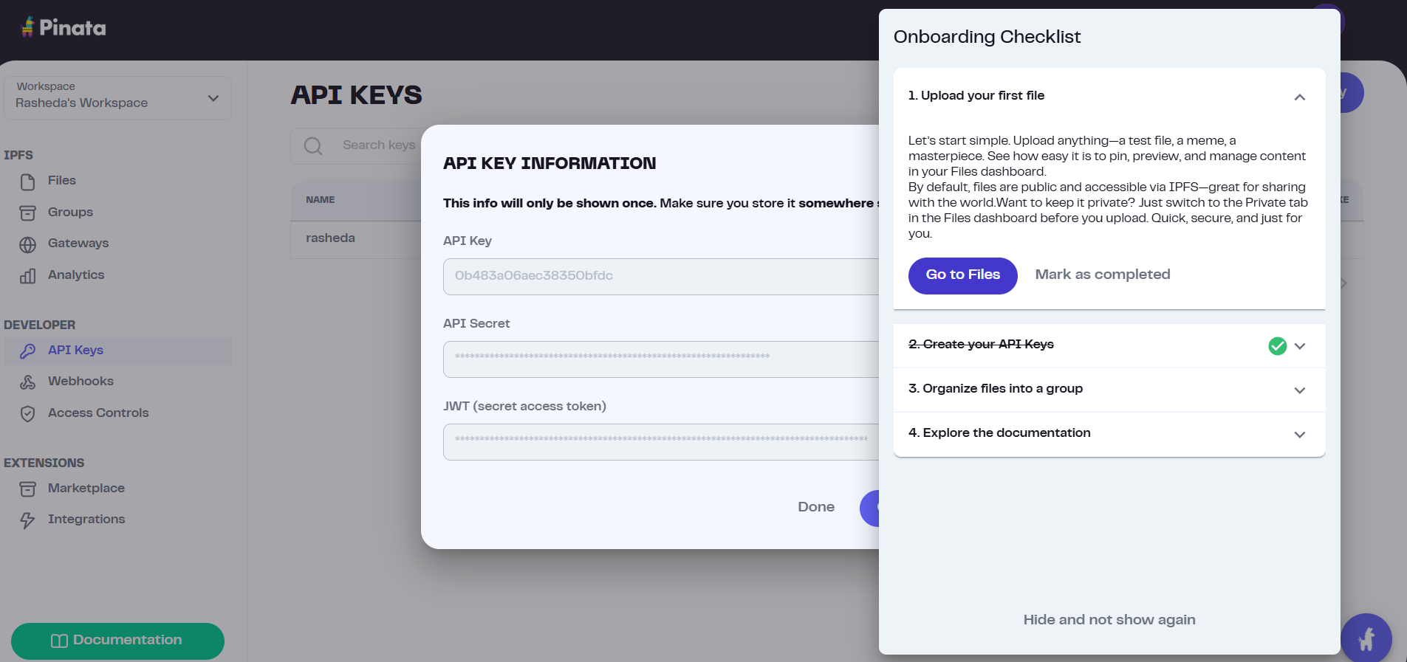

Implementation Phase: Final Output (no error)
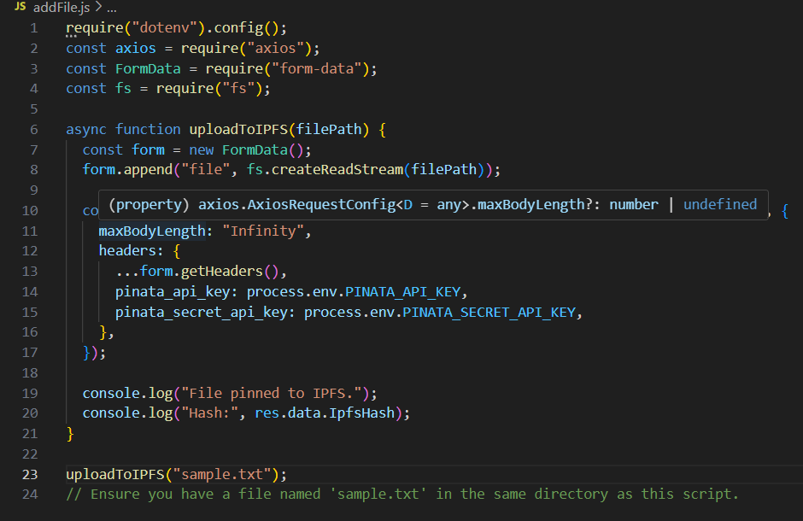

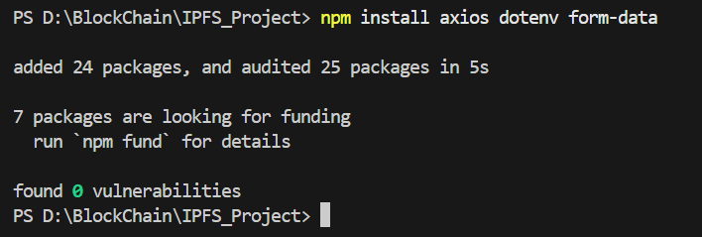

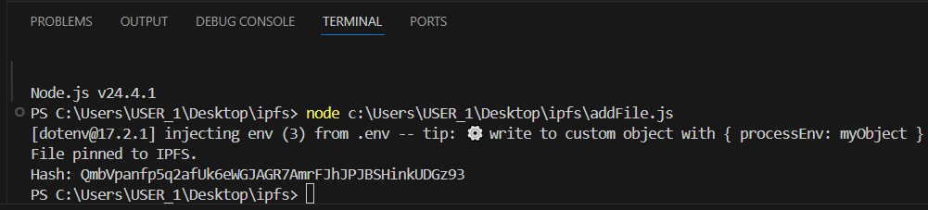
View the file CLL:

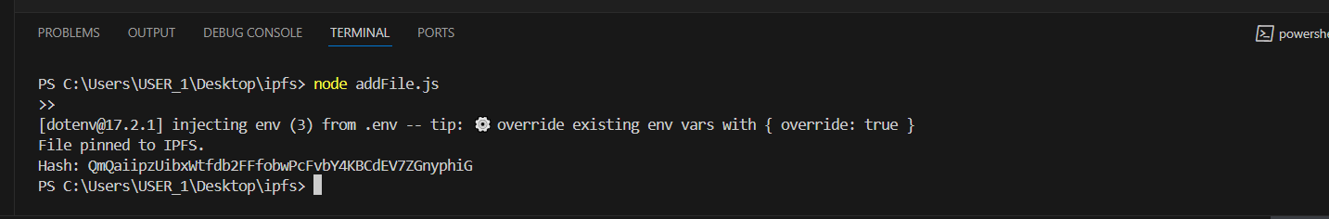

- Implementation Phase: Final Output (no error)
Applied and Action Learning

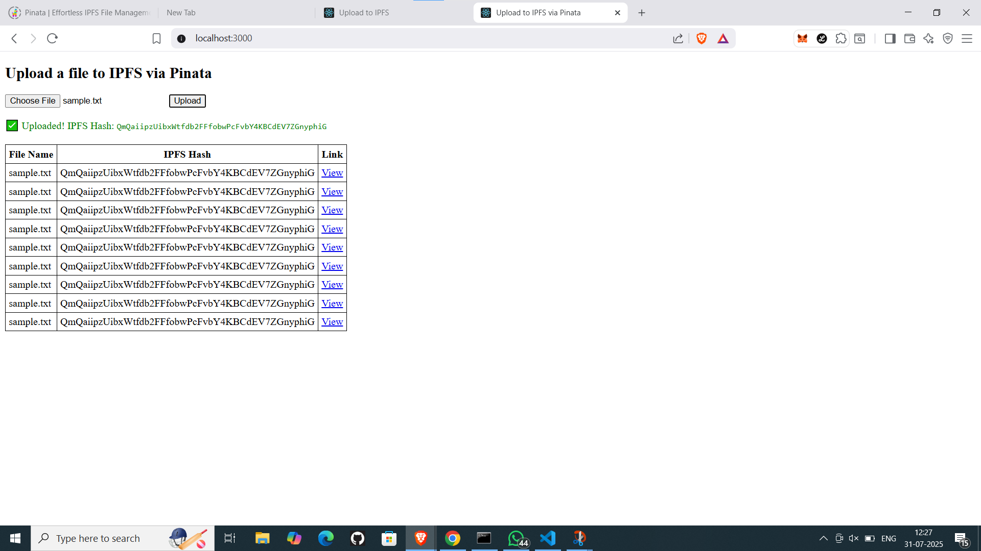

* Observations
Files can be uploaded directly from a web browser interface to a decentralized storage network (IPFS) and accessed later using a unique Content Identifier (CID), eliminating the dependency on centralized cloud storage providers.

ASSESMENT

Rubrics
Concept | 10
Planning and Execution/  Practical Simulation/ Programming | 10
Result and Interpretation | 10
Record of Applied and Action Learning | 10
Viva | 10
Total | 50


Signature of the Student:
Signature of the Faculty:

